OA
1. Objective
This OA is designed to test whether a candidate can handle realistic junior analyst tasks.
- clean messy datasets
- identify invalid data and suspicious outliers
- perform merge checks and inspect unmatched rows
- write reusable pandas functions
- understand and apply a simple fallback update pattern
- debug a spike through a simplified data pipeline
- write basic MySQL queries
This OA does not aim to test advanced algorithms. It is meant to reflect practical day-to-day work.

Don’t use any other package than that was imported
- Don’t change the main structure and template function definition, can use helper function if necessary.
- Implement your code in each A1.py, A2.py,A3.py

Questions

Part A — Python (75%)
A1.1 Data Cleaning, Invalid Data Handling, and Outlier Review
You are given a raw dataset in raw_positions.csv.
Read the file and create a cleaned dataframe called clean_positions_df.
Your task is to:
- standardize column names
- convert important columns to appropriate data types
- identify duplicate keys
You should return:
- a cleaned dataframe
- a dataframe of flagged issues
- a short summary of issues found, and actions taken

A1.2 Merge Task with Indicator Check
Using clean_holdings you got from previous step and ticker_map.csv.
Merge the positions dataset with the ticker_map and map all the child tickers in ticker_map to their parent tickers.
You must use the merge indicator feature to inspect the merge result.
Create:
- a merged dataframe called merged_df
- a dataframe called matched_positions_df containing rows from positions that did not match the security master
- a short summary of the merge result
A1.3 Vectorized Validation Function
Implement a function called validate_columns(df, rules).
The function should validate a dataframe based on a given rules dictionary and return a dataframe of exceptions. And do it in an efficient way.
The rules may include checks such as:
- minimum value: like price is no less than 0
- maximum value: outlier
- allowed values?
- non-invalid requirements: drop the invalid values like None,N/A, NaN
Use pandas operations as much as possible. Clear and efficient logic is preferred over row-by-row loops.

A2 Debug Task: Trace a n empty chart Through a Simple Pipeline and trace back source data.
Questions A2.1
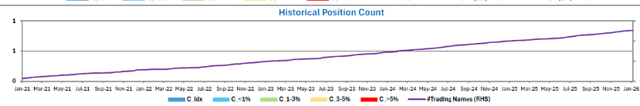This is a chart in our daily report, looks like the position count is all 0, help me check the issue and the reason behind (bugs? Source table?)
Explain the reason in the main function of Q2.py, change and comment on the script if needed. Just don’t change the input and output of prepare_position_data(df) and pm_hist(df)
Ps. The chart uses the “num_pos” in data\pm_hist_OA.csv (not including the whole period data, just partial) and Q2.py is the script of how we generated the pm_hist from upstream data – citcoposition_OA.csv.

Questions A2.2
RMs need your help to trace back the data coz they have some doubts on the source data. Which positon data in df_citcoposition contributes the biggest PnL on 02/24/2022 among all PMs,

A3
Debug and fix Task: fix the issue of tuple fails to use for query when tuple only gets one element (ticker,).
Questions A3
You are given a python function A3.py and sometimes get error when querying if some PM’s ticker list only get one ticker.
Help me identify the bug in the code and change the code to fix the bug ( try your best to not change the current way of implementing

Part B — SQL (25%)
We have a database table named [HistoricalAum] that stores historical Assets Under Management (AUM) for various Portfolio Managers (PMs). Each time a PM’s AUM is updated, new records are inserted into the table rather than replacing existing ones. Please refer to the sample below for the expected data structure. You are asked to complete the following tasks to retrieve the required AUM attributes.
Retrieve the most recent AUM under each PM for the fund 'MSIF' prior to a specified date.
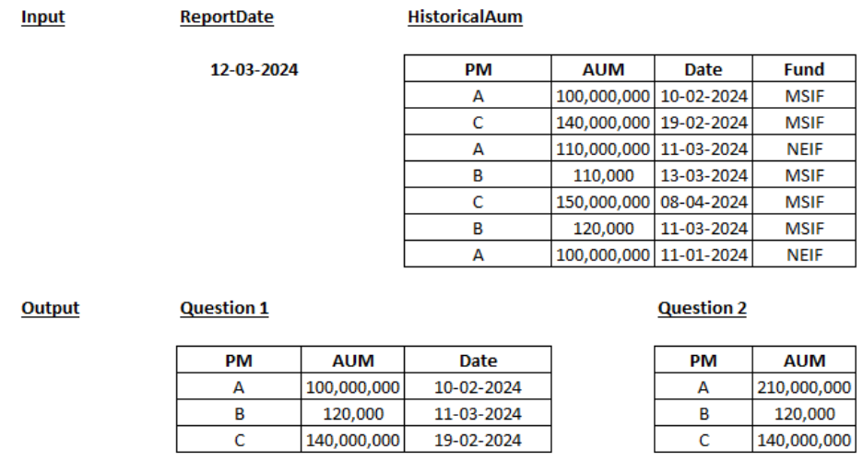
Retrieve the total AUM managed by each Portfolio Manager across all funds, considering only records dated before March 12, 2024.

OA
1. Objective
This OA is designed to test whether a candidate can handle realistic junior analyst tasks.
- Clean messy datasets
- Identify invalid data and suspicious outliers
- Perform merge checks and inspect unmatched rows
- Write reusable pandas functions
- Understand and apply a simple fallback update pattern
- Debug a spike through a simplified data pipeline
- Write basic MySQL queries

This OA does not aim to test advanced algorithms. It is meant to reflect practical day-to-day work.
Note:
- Don’t use any other package than that was imported
- Don’t change the main structure and template function definition, can use helper function if necessary.
- Implement your code in the python files provided according to the question number: A1.py, A2.py, A3.py

Questions

Part A — Python (75%)
A1.1 Data Cleaning, Invalid Data Handling, and Outlier Review
You are given a raw dataset in raw_positions.csv.
Read the file and create a cleaned dataframe called clean_positions_df.
Your task is to perform necessary data cleaning and document a short summary of issues found in the raw dataset, the process and assumptions applied.

- standardize column names
- convert important columns to appropriate data types
- identify duplicate keys
You should return:
- a cleaned dataframe
- a dataframe of flagged issues

A1.2 Merge Task with Indicator Check
Using clean_positions_df you got from the previous step and ticker_map.csv, merge the positions dataset with the ticker_map and map all the child tickers in ticker_map to their parent tickers.
You must use the merge indicator feature to inspect the merge result.
Your task is to merge the datasets and document a short summary of the results and what it shows.
You should return:
- a merged dataframe called merged_df
- a dataframe called matched_positions_df containing the all rows with issues
New:
You are given 2 dataframes:
- df_original with columns: id, value
- df_override with columns: id, value_override

Your task is to write a function, override_values. Construct the final value by substituting override values only for matching IDs, otherwise retain the existing values. Your output must contain only IDs present in df_original.
You should return a dataframe containing the columns ‘ID’ and ‘Value’.

A1.3 Vectorized Validation Function
Implement a function called validate_columns(df, rules).
The function should validate a dataframe based on a given rules dictionary and return a validated dataframe and a dataframe of exceptions. And do it in an efficient way.
The rules may include checks such as:
- Range checks: values must be within a certain range
- Allowed values: values can only be certain values (Eg: 0, 1 & 2)
- Valid values: invalid values have to be flagged out (Eg: NaN)
minimum value: like price is no less than 0
maximum value: outlier
allowed values?
non-invalid requirements: drop the invalid values like None, N/A, NaN
Use pandas operations as much as possible. Clear and efficient logic is preferred over row-by-row loops.
You should return:
- a validated dataframe
- a dataframe of flagged issues

New:
The risk team deals with a large amount of data everyday. We need some sanity checks in place to ensure the data we are dealing with is accurate. Implement 2 functions named range_check and non_desc to validate any dataset. Design the functions to achieve optimal running-time efficiency and explain your design.
range_check: Validate that values in a specified column fall within a defined minimum and maximum range.
non_desc: Validate that values in a specified column are non-decreasing over time.
Both functions should return a dataframe containing rows that have been flagged out as invalid.

A2 Debug Task: Trace an empty chart Through a Simple Pipeline and trace back source data.
Questions A2.1
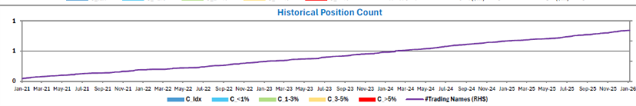This is a chart in our daily report, looks like the position count is all 0, help me check the issue and the reason behind (bugs? Source table?)
Explain the reason in the main function of Q2.py, change and comment on the script if needed. Just don’t change the input and output of prepare_position_data(df) and pm_hist(df)
Ps. The chart uses the “num_pos” in data\pm_hist_OA.csv (not including the whole period data, just partial) and Q2.py is the script of how we generated the pm_hist from upstream data – citcoposition_OA.csv.
This is a chart in our daily report, the position count(C) is all 0 (in the graph, ‘C_Idx’, ‘C_<1%’ etc. are not plotted on the graph), find the reason behind this.
If there is a bug in A2.py, explain where and change and comment on the script if needed. Do not change the input and output of ‘prepare_position_data’ and ‘pm_hist’ function.

Note:
The chart uses the data from column named “num_pos” in pm_hist_OA.csv . Only a subset of the time period is included, rather than the full time series.
A2.py is the script of how the data was processed from citcoposition_OA.csv to later analysis test.
A2.py contains the functions to process data from citcoposition_OA.csv. The output is pm_hist_OA.csv and is used for future analysis testing.

Questions A2.2
RMs need your help to trace back the data coz they have some doubts on the source data. Which positon data in df_citcoposition contributes the biggest PnL on 02/24/2022 among all PMs.

A3
Debug and fix Task: fix the issue of tuple fails to use for query when tuple only gets one element (ticker,).
Questions A3
You are given a python function A3.py and sometimes get error when querying if some PM’s ticker list only get one ticker.
Help me identify the bug in the code and change the code to fix the bug ( try your best to not change the current way of implementing
You are given a python function A3.py. There is a bug when creating the sql query (sql_trade_affected) that causes errors when ticker_list is of length 1. Explain why this error occurs and fix the code by adding code only (do not remove anything from the current template).

Part B — SQL (25%)
We have a database table named [HistoricalAum] that stores historical Assets Under Management (AUM) for various Portfolio Managers (PMs). Each time a PM’s AUM is updated, new records are inserted into the table rather than replacing existing ones. Please refer to the sample below for the expected data structure. You are asked to complete the following tasks to retrieve the required AUM attributes.
Retrieve the most recent AUM under each PM for the fund 'MSIF' prior to a specified date.
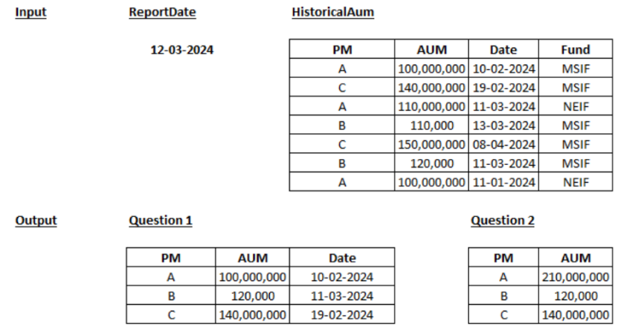
Retrieve the total AUM managed by each Portfolio Manager across all funds, considering only records dated before March 12, 2024.

